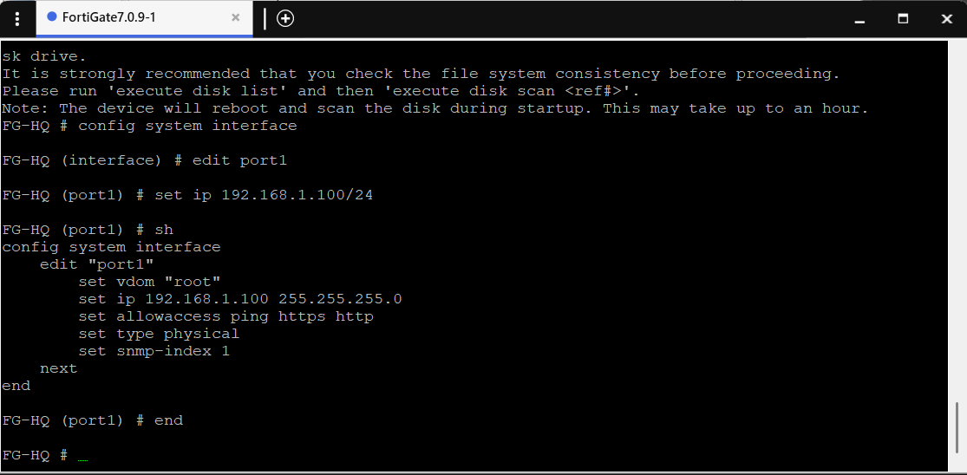

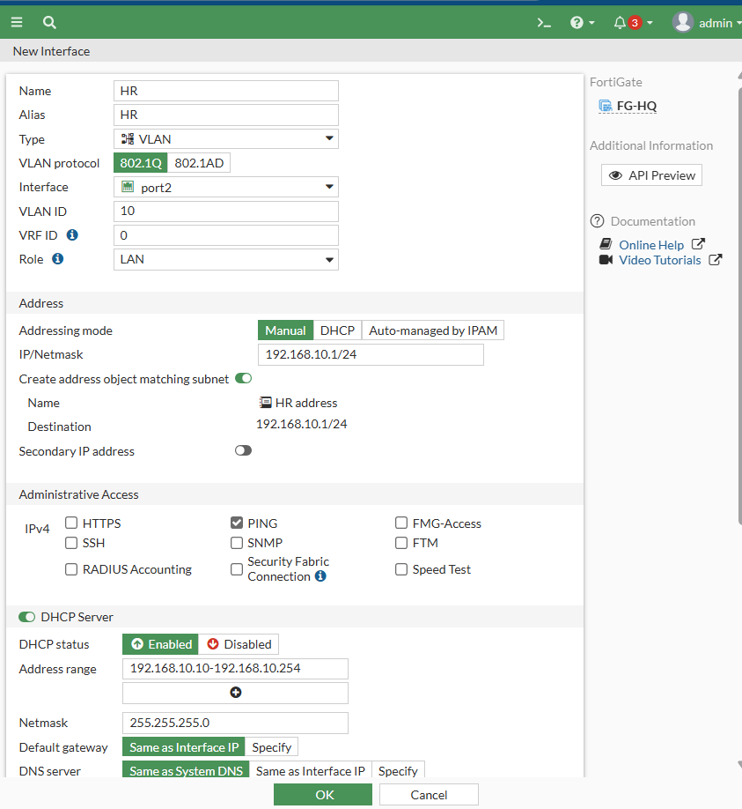

>>>IOU1 CONFIGURATIONS

Creating vlans

Trunk &access interfaces

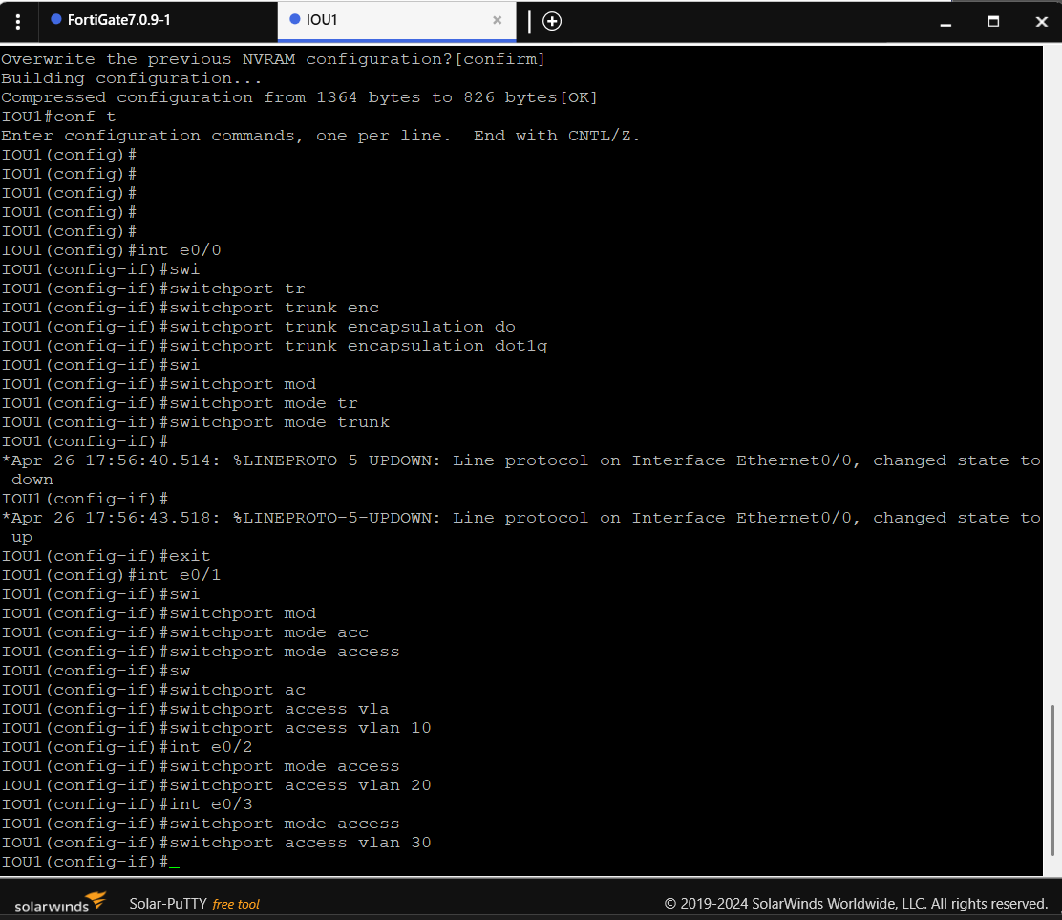

Taking ip from dhcp

Pc1

Pc2

Pc3

Configuring inter-vlan on fortigate

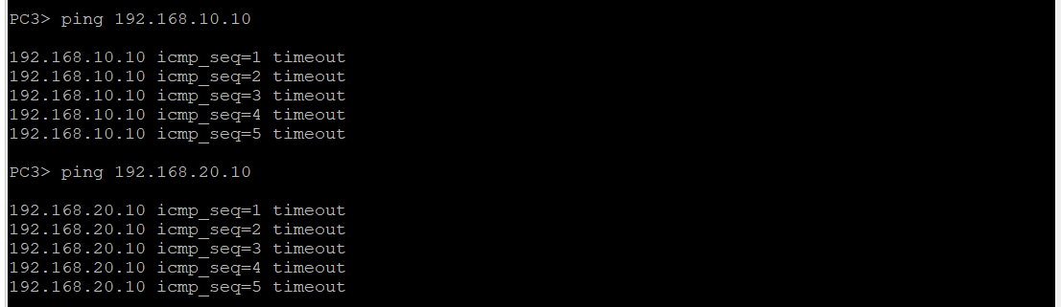

We need to configure inter-vlan so that they can reach each other

Disable Block intra-zone traffic

Pc3 now can ping pc2 and pc1 (intervlan)

Configuring second fortigate

CREATING VLANS

Iou2 configuration

Creating vlans

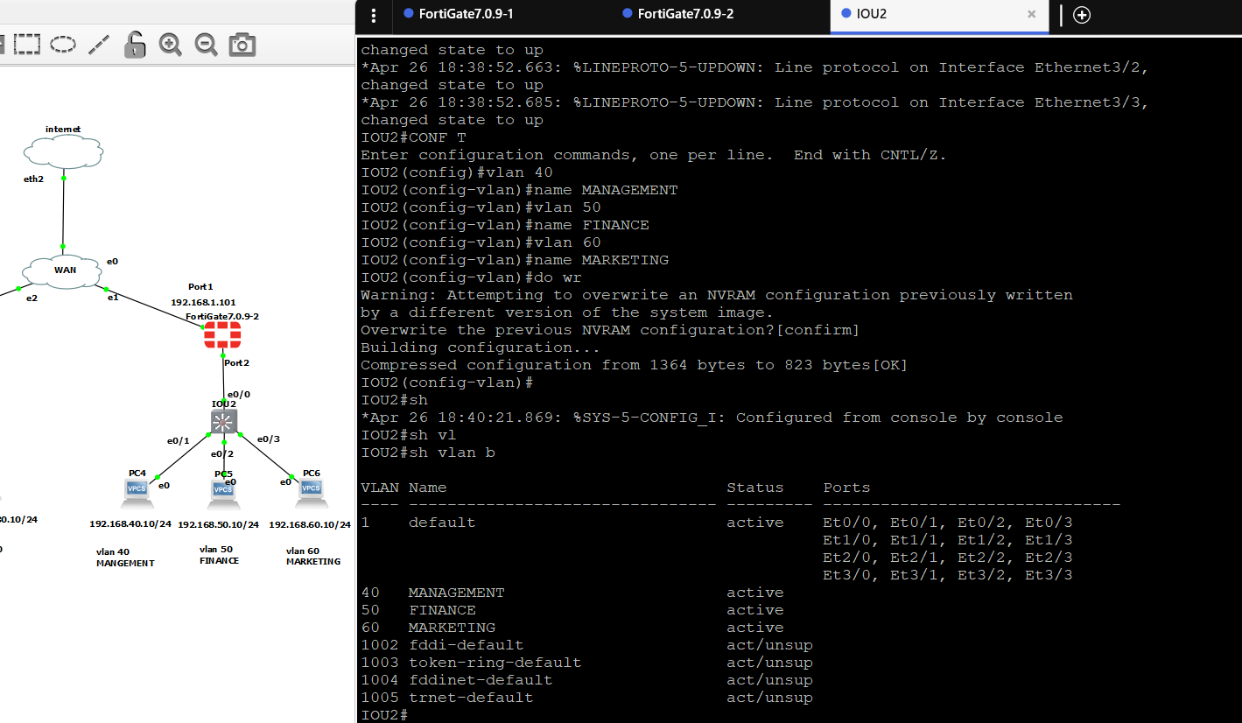

Taking ip from dhcp

Configuring inter-vlan

Now pc6,pc5,pc4 can communicate with each other but can’t communicate with devices on the other branch(FG-HQ)

So we need to configure site-to-site vpn

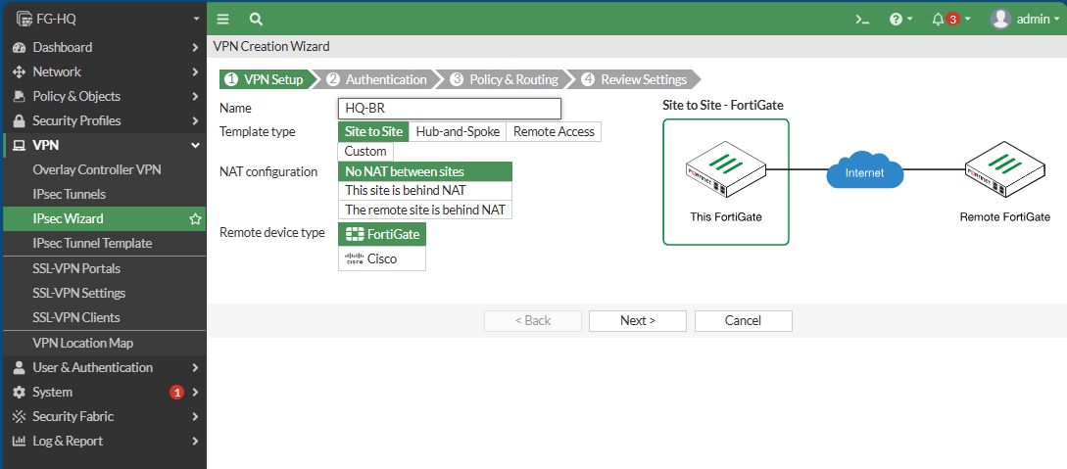

After creating vpn a static route&firewall policy are created automatically

>>Doing the same on FG-BR

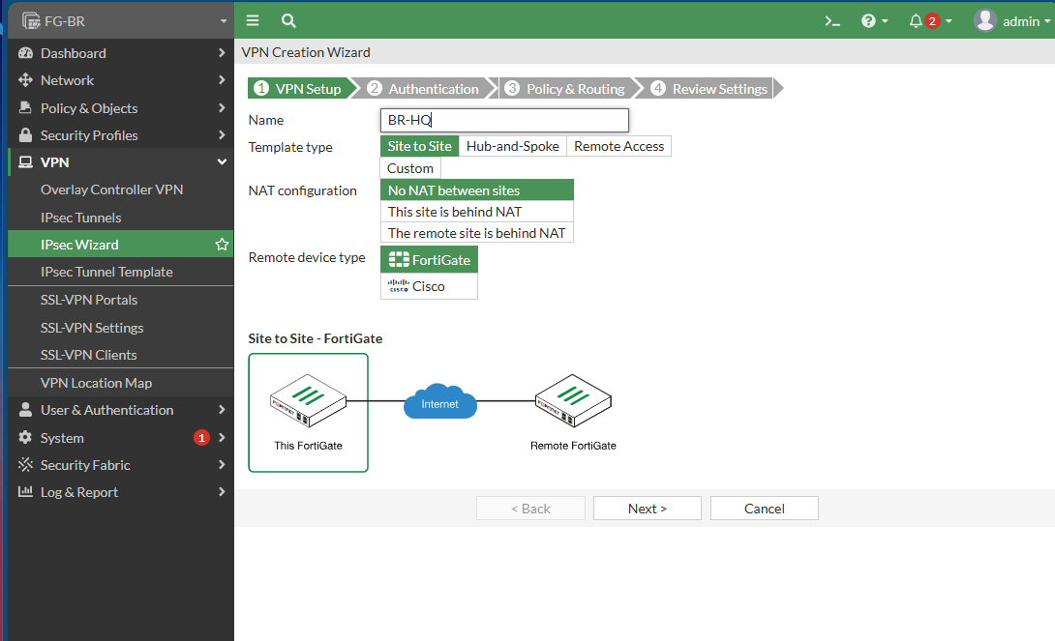

Now lets test ping from pc5(vlan50) to pc1(vlan10)

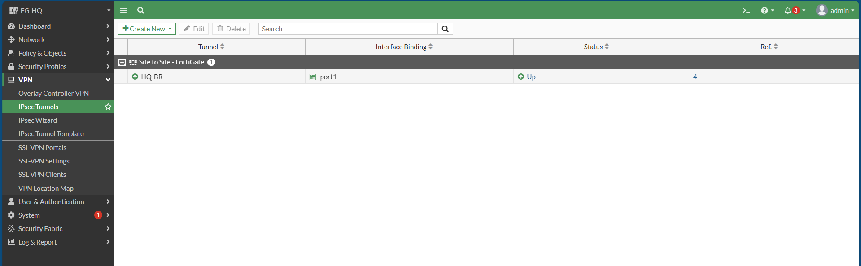

**>>>>>Network Scaling**

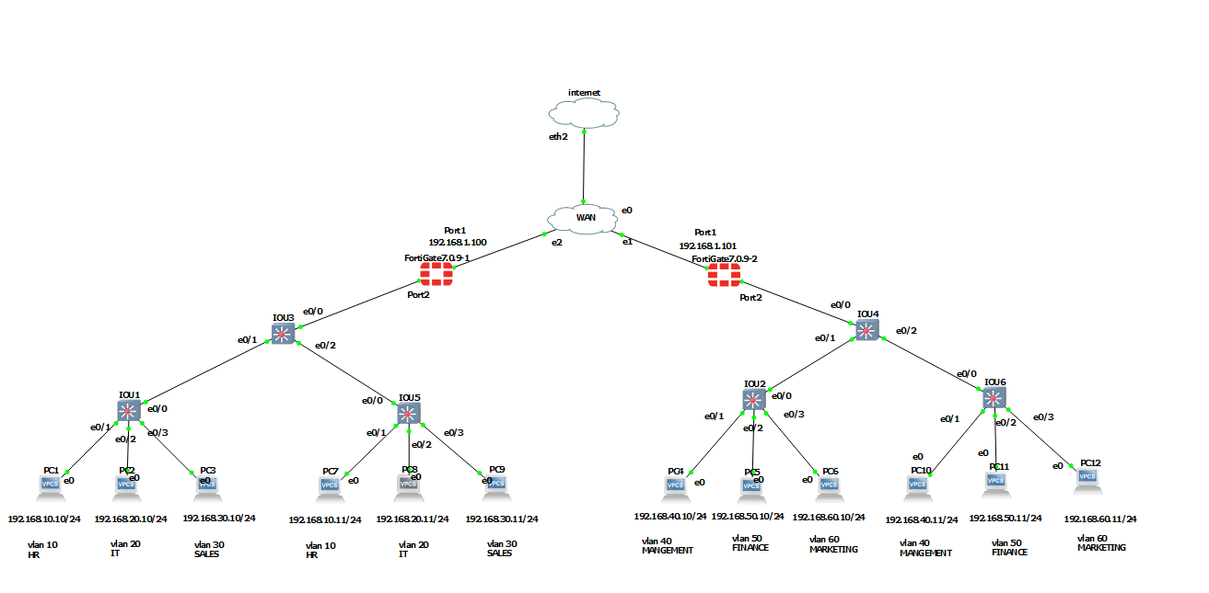

>Iou5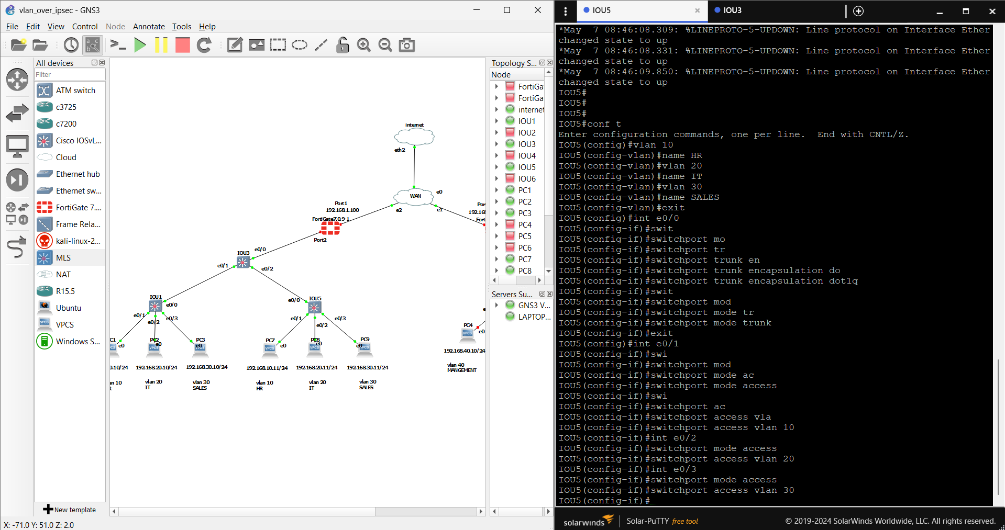

>Iou3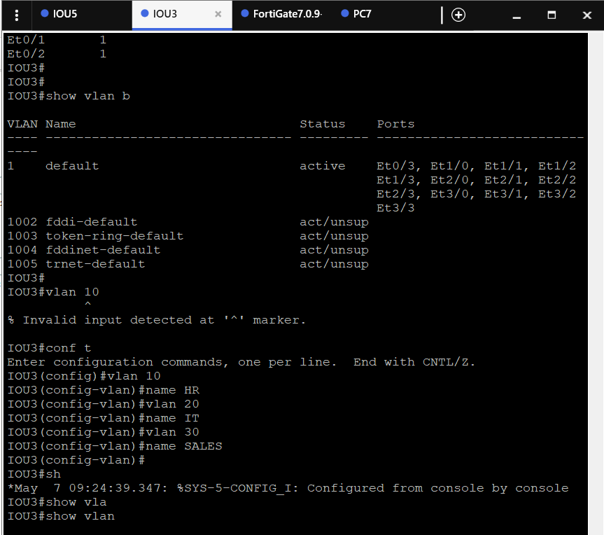

Pc7 taking ip(dhcp)

Pc8 taking ip

Pc9 taking ip

>>FG-BR

>Iou4

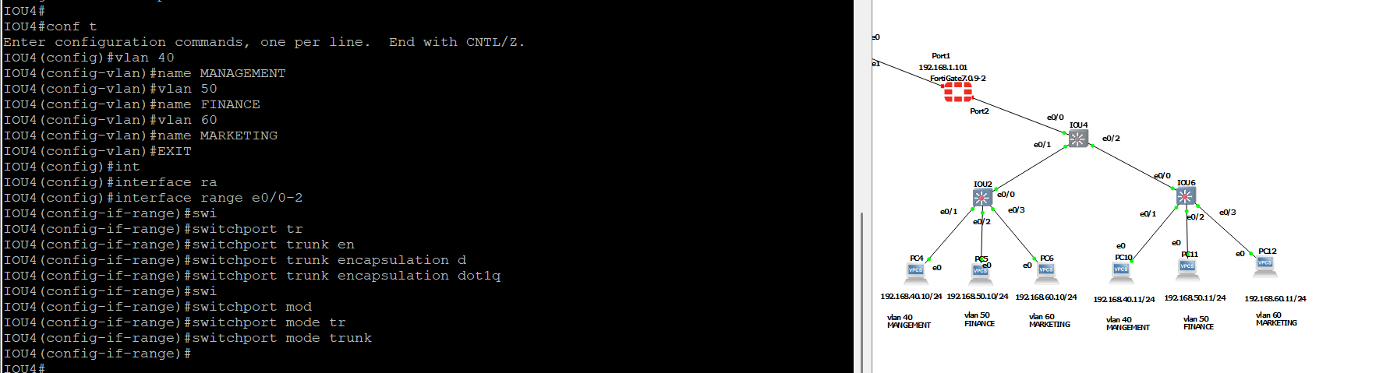

>iou6

Pc 10,11,12 taking ip(dhcp)

>>>Test ping

Pc 10 ping devices on the same branch

>>ping from branch to branch

Pc10(192.168.40.11)

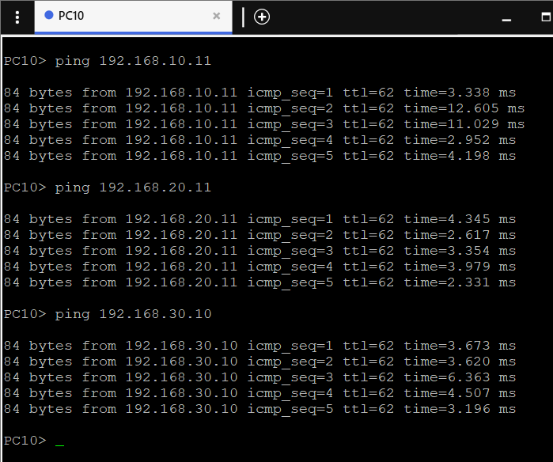

Pc12(192.168.60.11)

Pc8(192.168.20.11)

